Mineral Resource

Table 1: Total Mineral Resource Estimate for Sandstone Gold Project, March 2022
JORC 2012 Mineral Resource Estimate for the Sandstone Gold Project as at March 2022
Classification | Tonnes (Mt) | Grade (g/t gold) | Contained gold (koz)
Total Indicated | 3.0 | 1.7 | 159
Total Inferred | 9.4 | 1.6 | 476
TOTAL | 12.4 | 1.6 | 635
Updated Mineral Resources reported at a cut-off grade of 0.5 g/t gold. Mineral Resources for Indomitable are reported at a cut-off grade of 0.3 g/t gold. Minor discrepancies may occur due to rounding of appropriate significant figures.

Table 2: Total Mineral Resource Estimate for Sandstone Gold Project, March 2022 (by deposit)
 | Indicated |  |  | Inferred |  |  | Total
Deposit | Tonnage (Mt) | Grade g/t | Gold  (koz) | Tonnage (Mt) | Grade g/t | Gold  (koz) | Tonnage (Mt) | Grade g/t | Gold  (koz)
Lord Nelson | 1.0 | 1.8 | 56 | 4.3 | 1.5 | 211 | 5.3 | 1.6 | 267
Lord Henry | 1.6 | 1.5 | 77 | 0.3 | 1.2 | 13 | 1.9 | 1.4 | 90
Vanguard Camp | 0.4 | 2.0 | 26 | 1.9 | 2.0 | 124 | 2.3 | 2.0 | 150
Havilah Camp |  |  |  | 1.0 | 1.5 | 46 | 1.0 | 1.5 | 46
Indomitable Campª |  |  |  | 1.7 | 1.3 | 74 | 1.7 | 1.3 | 74
Ladybird^{b} |  |  |  | 0.1 | 1.9 | 8 | 0.1 | 1.9 | 8
TOTAL | 3.0 | 1.7 | 159 | 9.4 | 1.6 | 476 | 12.4 | 1.6 | 635
Updated Mineral Resources reported at a cut-off grade of 0.5 g/t gold and are constrained within a A$2,500/oz optimised pit shells based on mining parameters and operating costs typical for Australian open pit extraction deposits of a similar scale and geology. Mineral Resources for Indomitable (reported at a cut-off grade of 0.3 g/t gold) and Ladybird deposits have not been updated. Minor discrepancies may occur due to rounding of appropriate significant figures.
The references in this announcement to Mineral Resource estimates for the Sandstone Gold Project were reported in accordance with Listing Rule 5.8 in the following announcements:
(a): Indomitable & Vanguard Camp: announcement titled: "Maiden Gold Resource at Indomitable & Vanguard Camps, Sandstone WA" 25 Sep 2018; and
(b): Havilah & Ladybird: announcement titled: “Alto increases Total Mineral Resource Estimate to 290,000oz, Sandstone Gold Project” 11 June 2019.
The Company confirms that it is not aware of any new information or data that materially affects the information included in the previous market announcement noted above and that all material assumptions and technical parameters underpinning the Mineral Resource estimates in the previous market announcement continue to apply and have not materially changed.

Table 3: Mineral Resource Estimate March 2022 Grade and Tonnage by cut-off grade within the optimised pit (excl. Indomitable & Ladybird)¹
Cut-off grade (g/t gold) | Tonnage (Mt) | Grade (g/t gold) | Contained gold (koz)
0.3 | 10.8 | 1.6 | 557
0.5 | 10.5 | 1.6 | 553
0.8 | 8.5 | 1.9 | 510
All tonnages are reported in dry metric tonnes. Minor discrepancies may occur due to rounding of appropriate significant figures.
1 Table 3 shows the total grade and tonnage by cut-off grade for the updated deposits in this release only. The estimates for Indomitable Camp and Ladybird are excluded from this table as grade tonnage cut-off grades were not included in the release for these mineral resource estimates

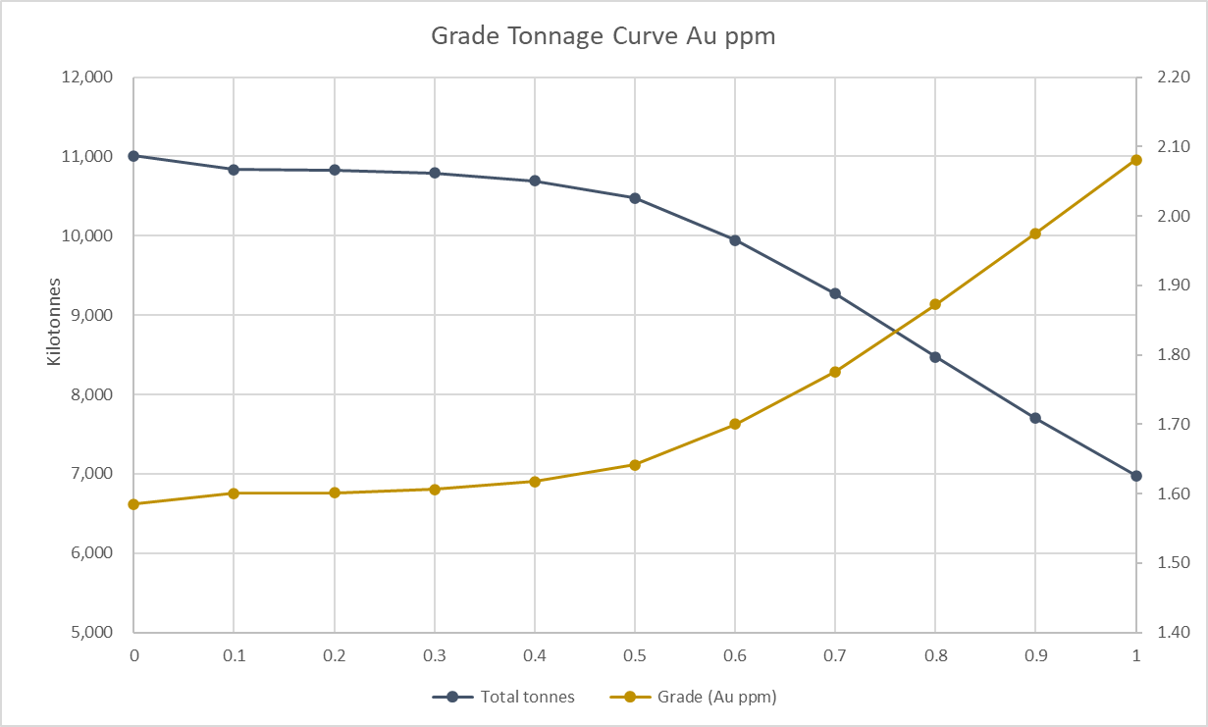
Figure 1: Sandstone Gold Project – grade tonnage curve (excl. Indomitable & Ladybird)¹

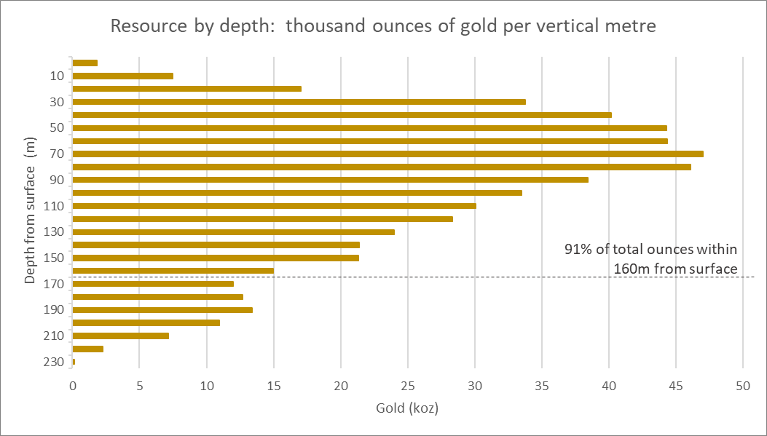
Figure 2: Sandstone Gold Project – Total ounces per vertical metre.

